**Understanding Ecological Invasions on Complex Networks**

**1.** **Abstract (No more than 250 words)**

Every day, foreign species are brought into Singapore, and these foreign species have the potential to become invasive, which will cause significant damage to biodiversity, economy and animal and human health of the invaded environment. Yet, it remains uncertain if ecological invasion is easy. Hence, to address this uncertainty, we build a complex network model of ecological invasion by simulating food webs and ecological invasion across two different ecosystems with the use of Python. In the simulations, with some assumptions and limitations, we randomly generate the food webs and do the invasions to find out in which condition the species will be easier to invade to a ecosystem. Finally, we will improve our model and apply into real world.

**2.** **Introduction (Background and Purpose of Research Area)**

[This section includes theoretical background from literature review, leading to your research aim and hypothesis.]

Every day, foreign species are brought into Singapore, especially viral pathogens that are introduced by tourists and workers. Foreign species have the potential to become invasive species, and this new addition would spearhead a chain of changes in the invaded environment, eventually leading to loss a of genetic, species and ecosystem diversity1. Additionally, they pose a considerable threat to agricultural production, infrastructure, and animal and human health2. Recently, the Channel News Asia has brought to public attention sightings of the Red-billed Quelea (Quelea quelea), the ‘most destructive bird species in the world’, that was blamed for significantly reducing weaver and munia populations in Singapore3. In addition, ecological invasion has also cost $100 billion each year in US, and over £239 million in the UK alone4. Annual economical losses from ecological invasions have also been calculated to be much higher than losses due to natural disasters5.

Although it is true that invasive species may have destructive effects on the environment and economy, most foreign species actually die out quickly and are unable to adapt to the new environment. In particular, by sequencing the genomes of viruses found in confirmed dengue patients, and then building a phylogenetic tree, we know that most dengue cases are caused by our native dengue viruses. Foreign dengue strains are never really able to establish themselves.

So is it easy or hard for foreign species to establish themselves, and become invasive? We believe invasion is actually a hard thing to do, since most foreign species die out without establishing themselves. Thus, to understand ecological invasion, and identify the necessary and sufficient conditions for a foreign species to become invasive, in this study, we build a complex network model of ecological invasion by simulating food webs and ecological invasion across two different ecosystems via the use of the Networkx module in Python as well as Gephi.

**3.** **Materials and Methods**

[This section includes the experiments, techniques or modes of inquiry conducted during the research. Data sources, how they are collected and evidences are presented in tables, figures, graphs or diagrams (with proper captions provided).]

As we are not focusing on specific food webs, we decided to use ython script to generate and matching the food web and simulate the developing of the ecosystem that can be altered, as this allows us to explore a wider range of food webs.

3.1 Assumptions:

Because of we are using generated food webs instead of real data, we have a few of assumptions:

1. Food web can be divided into serval **trophic levels**, any preys must be at a lower trophic level compared with their predator.
2. Any species in same trophic level will have same numbers of preys in the next trophic level, and the number will be given by a **function** related to the **numbers** of the species in this two trophic levels.
3. Species may have preys located on the trophic level much lower than itself, and the possibility of forming this relationship will **decrease very fast** and be given by a function which is same to all species in the food web.
4. The two food webs which are going to simulate a invasion can be very differently. Any species may invade into the other food web and replace the position of a species which is located at the **same** , one up or one down in **trophic level**.
5. All species will have its only "predation", "killed", "reproduction" and "senescence" function. These are the properties of a species.
6. All the progress are doing randomly but under the limitation of certain functions or formulas.

3.2 Artificial Ecosystem Generation

In this model, we have two ecosystems, the *origin ecosystem A*, and the *destination ecosystem B*, as shown below.

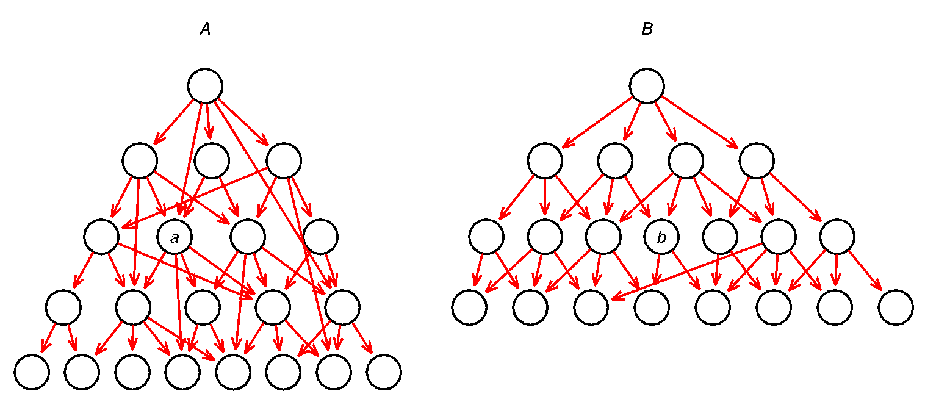

The two ecosystems need not be similar. They do not need to have the same total number of species, nor do they need to have the same number of trophic levels. More importantly, a species on trophic level 3 in *A* may be the equivalent of a species on trophic level 2 or 4 in *B*. Therefore, a species *a* on trophic level 3 in *A* can be most similar to species *b* on trophic level 3 in *B*, but it can also be most similar to species on trophic levels 2 or 4 in *B*. This mapping of most similar species in *A* and in *B* need not be complete, i.e. there are some species in *A* that are not mapped to any species in *B*, and vice versa. This gives us the freedom to map species between *A* and *B*.

After developing the structure of each food web using Python’s NetworkX module, we set the total number of species in each food web as x, and proceeded to manually carry out species mapping. (in progress)

3.3 Model parameters (in progress)

At the same time, we developed a differential equation for our simulation to follow. The equation takes into consideration the following variables:

1. Growth rate of each species in absence of prey/predator
2. Death rate of each species in absence of predator
3. Effect of prey on each species
4. Predation efficiency on each species

3.4 Simulations(to be carried out after differential equation is fixed)

3.5 Scripts:

Here are the the scripts we have:

1. **Generator**: This script will generate a food web according the numbers of species in each **trophic level**. With an input of the increasing numbers of the species one trophic level by one level, any food web can be generated . The script will generated a basic web -- all species having their preys in sequence, and no species will have a prey on any trophic level instead of the one next to it -- initially, and take a possibility to swap the relationship of predation. Then, add some relationship across the levels according to the possibility function. The output will be in a pure text file with a JPEG image.
2. **Matcher**: This script will list all the available position in *destination* food web for the species in the *original* food web to invade. Output will be a list of numbers of available positions in a pure text file for each species in *original* food web.
3. **Simulator**(in progress): This script will assign properties for each species and run the simulation to check whether it is a successful invitation. Or we will using the differential equation for the simulation.

**4.** **Results and Discussion (Interpretation of Data, Results and Findings)**

**5.** **Conclusion and Future Work (Conclusions and Recommendations)**

Future Work:

1. Check with real data
2. Increasing the accuracy of model
3. Apply into real work

**6.** **Bibliography of References (in APS format)**

1. Qian, H., & Ricklefs, R. E. (2006). The role of exotic species in homogenizing the North American flora. *Ecology Letters*, *9*(12), 1293-1298. [20 Aug. 2015]

2. Pimentel, D., Zuniga, R., & Morrison, D. (2005). Update on the environmental and economic costs associated with alien-invasive species in the United States. *Ecological economics*, *52*(3), 273-288. [21 Aug. 2015]

3. Neo C. Fears grow that invasive bird species may cause havoc here [Online]. *Channel NewsAsia* 2015. http://www.channelnewsasia.com/news/singapore/fears-grow-that-invasive/1848736.html [20 Aug. 2015].

4. White, P. C., & Harris, S. (2002). Economic and environmental costs of alien vertebrate species in Britain. *Biological Invasions: Economic and Environmental Costs of Alien Plant, Animal and Microbe Species*, 91-112. [20 Aug. 2015]

5. Ricciardi, A., Palmer, M. E., & Yan, N. D. (2011). Should biological invasions be managed as natural disasters?. *BioScience*, *61*(4), 312-317. [20 Aug. 2015]

**7.** **Appendices**

Python Modules (third party’s) used:

Python Image Library (PIL) for visualization

NetworkX for fast program and visualization

Softwares used:

Gephi